Required Practical Activity:
Density 3

Note:
This resource is designed as a review of the required practical activity, covering all possible skills that could be developed through the investigation. This resource can be adapted to suit the needs of your class, depending on which skills your class need support with.

In this investigation we will use measurements of volume and mass to determine the density of a liquid.

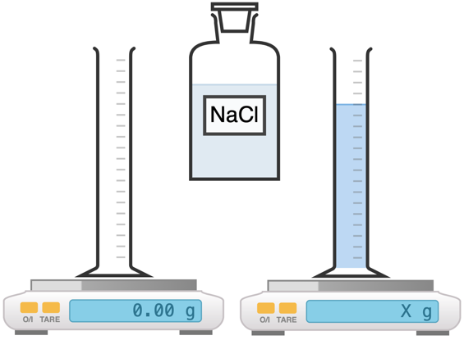

Method:

- Use the digital mass balance to measure the mass of an empty 100 ml measuring cylinder.
- Add approximately 100 ml of salt solution to the measuring cylinder and record the exact volume in your results table.
- Record the new mass of the measuring cylinder plus 100 ml of liquid and use this data to calculate the mass of the liquid.
- Calculate and then record the density of the liquid using the equation: density = mass/volume.
- Convert your density measurements into the standard units of kg/m³.

- Equipment:
- What measurements need to be taken in this investigation? | The volume of liquid, the mass of the liquid.
- What is the most suitable piece of apparatus to take measurements with? Why? | A plastic measuring cylinder is accurate to 1 ml and is of sufficient resolution to measure the volume of the liquid.  A mass balance accurate 0.1 g or 0.01 g is of sufficient resolution to measure the mass of the object.
- Identify any hazards in this investigation. | Ensure the mass balance is able to withstand the weight of your liquid. Some very sensitive balances can be damaged if too much force is applied.  If any water is spilled, clean it up immediately so as to avoid damaging electronic equipment or causing a trip hazard.
- Why is it important that the balance is properly zeroed before weighing your object? | If the balance is improperly zeroed it will not give an accurate measurement of the weight of the object. Zero the balance before placing any objects on the balance.
- What units will we use for measuring the volume of liquid? | Millilitres (ml) or centimetres cubed (cm³).
- What is the relationship between 1 cm³ and 1 ml? | They are equal.
- What is the difference between weight and mass? | Weight is the downward force of gravity on the mass. Mass will always be constant, whereas the force of weight will differ with gravity, for instance on other planets.
- What is the equation to calculate density? | Density = mass / volume
- What will be our units for density if we measure mass in grams (g) and length in centimetres (cm)? | Grams per centimetre cubed, or g/cm³, or g.cm⁻³
- What are the S.I. units for density? | Kilograms per metre cubed, or kg/m³, or kg.m⁻³

- Results
Liquid | Volume (cm³) | Mass of empty measuring cylinder  (g) | Mass of measuring cylinder plus liquid  (g) | Mass of liquid  (g) | Density  (g/cm³) | Density  (kg/m³)
NaCl solution | 100 | 40.3 | 152.0 | 111.7 | 1.117 | 1117

- Explain why it is appropriate to round measurements taken with a ruler to the nearest millimetre. | This is as precise a measurement as can be inferred from the readings.
- Is the density of the NaCl solution higher or lower than the density of pure water? | Higher.

